OCR GCE A

COMPUTER SCIENCE PROJECT

H446-03

Name : :3

Candidate Number : <INSERT CANDIDATE NUMBER>

<Institution Name> : <INSERT CENTRE NUMBER>

Title of Project : <INSERT PROJECT TITLE>

H446-03 – Project CONTENTS

Table of Contents

A. Analysis 3

B. Design 3

Systems diagram 3

C. Developing the coded solution (“The development story”) 3

D. Evaluation 3

Project Appendixes 4

# A. Analysis

## PrOBLEM Identification

The project I wish to complete is a 2.5D (Visually is 3D but in terms of mechanics is 2D) Top-Down puzzle game, where the player can explore a series of dungeons (caves) that will contain puzzles to access rooms, monsters that defends those rooms as well as an incentive to dive into these dungeons. The “loot” that can be earnt in these dungeons could be weapons, Armor, valuables, etc. The loot would be generated based on the “level” of the dungeon, the type of puzzles/enemies inside, and the player. The dungeons would also be generated. However, they would be generated procedurally with pre-made art/tiles, meaning it will be rare that two consecutive dungeons share the same structure.

## Stakeholders

The stakeholders for my project would be any gamers that may enjoy a puzzle/fighting game that will keep them entertained, for the stakeholders my game has to be enjoyable, and repeatable (They will want to come back and play it again after playing it), attractive (looks good so they will want to play it in the first place). The game has to, by the bare minimum, have a good game loop meaning the player can keep playing and the gameplay not cut off abruptly. The stakeholders will consist of casual gamers, since the game won’t be too intense or laid back it lands in the middle of competitive and relaxing games.

## Research

Games like my project idea already exist, such as “Hogwarts Legacy” which contains trials for the player. These trials are similar to my idea in the fact that they are a sort of dungeon that contains enemies and puzzles which rewards the player, it is also similar to “Dungeon and Puzzles”(2021) in which the character goes through dungeons and has to complete puzzles to advance further.

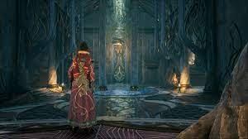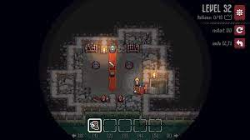

# B. Design

<See H446-03 Project Advice Booklet for help and guidance of what must go here.>

## Systems diagram

# C. Developing the coded solution (“The development story”)

<See H446-03 Project Advice Booklet for help and guidance of what must go here.>

# D. Evaluation

<See H446-03 Project Advice Booklet for help and guidance of what must go here.>

# Project Appendixes

Insert as many project appendixes as you need for your project.

These might include, but are not limited to:

* Complete Code Listing (ESSENTIAL)
* Interview Transcripts
* Meeting notes
* Observation notes or questionnaires